**PROJECT REPORT**

Title of the Project: **Unveiling Market Insights: Analyzing Spending Behavior and Identifying Opportunities for Growth**

* **INTRODUCTION:**
  + **Overview**

The theme of this project is to analyze the spending behavior of the customers and identify the opportunities which results in growth.

* + **Purpose**

The purpose of this project is to unveil the Market Insights i.e., to discover relevant, actionable and previously unrealized reality about a target market using subjective data analysis

* **PROBLEM DEFINITION & DESIGN THINKING:**
  + **Empathy Map**

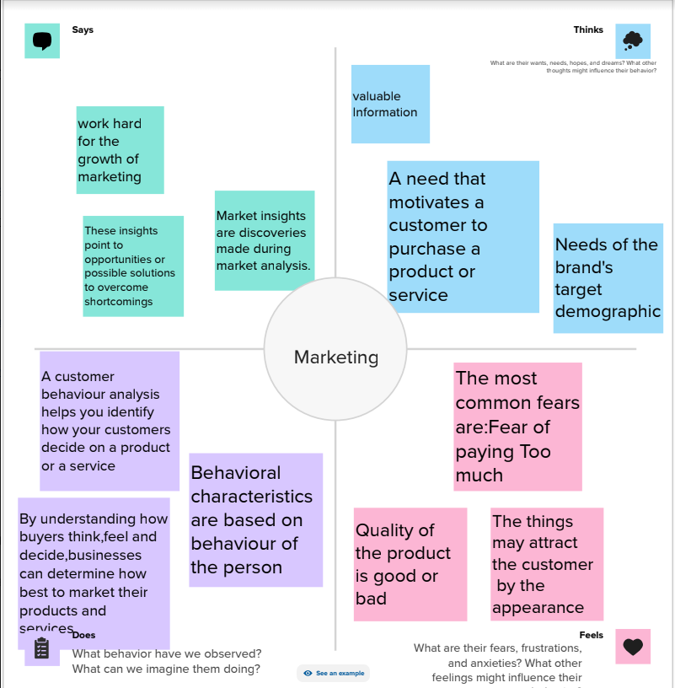

* + **Ideation & Brainstorming map**

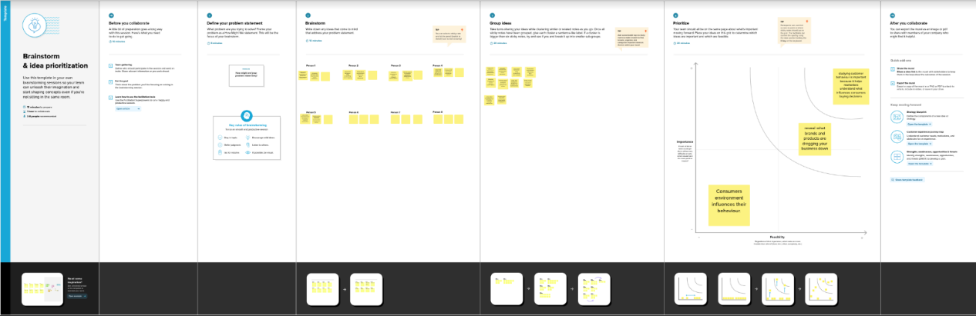

* **RESULT:**

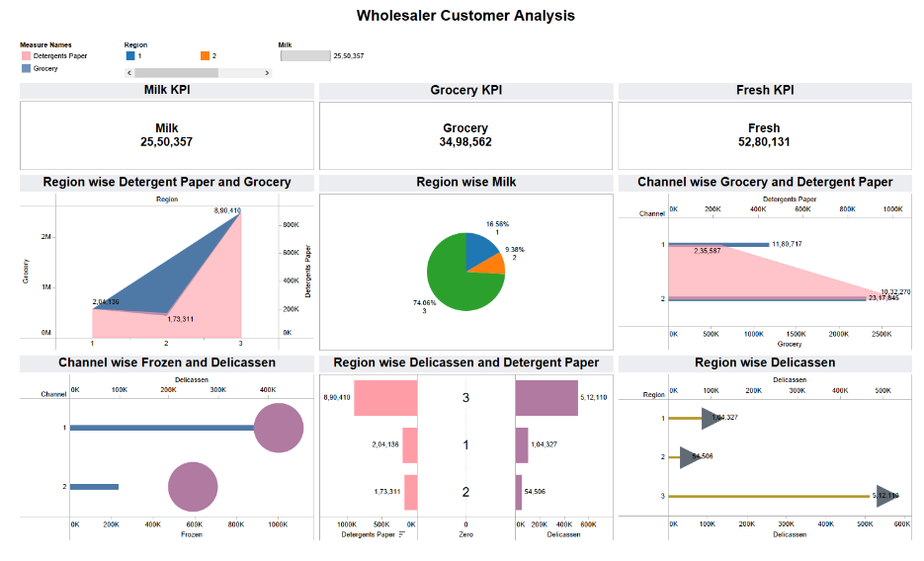

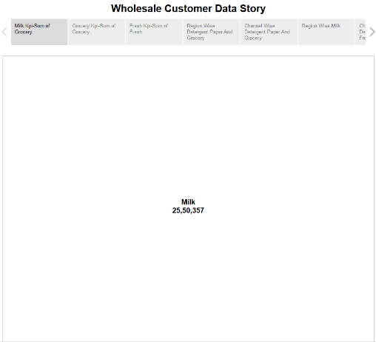 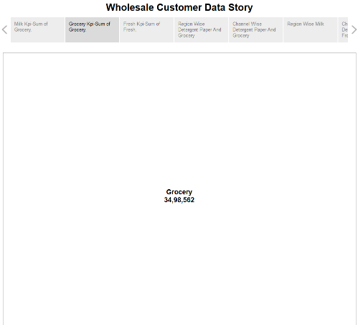

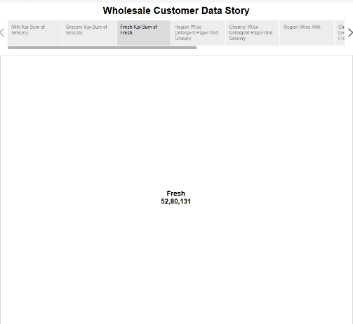 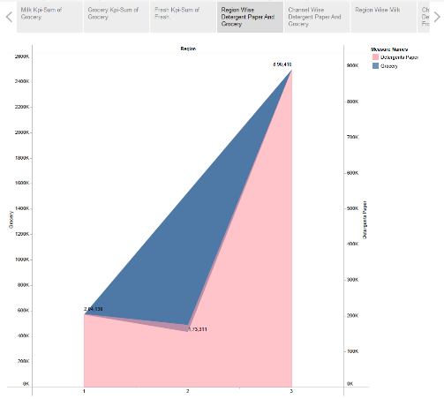

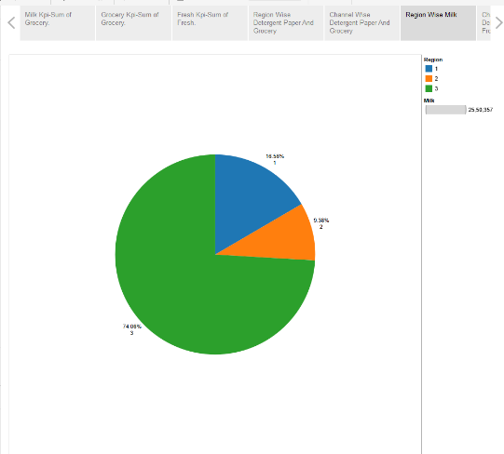 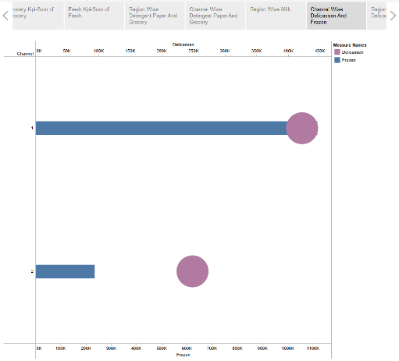

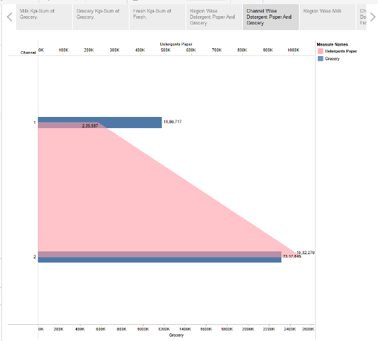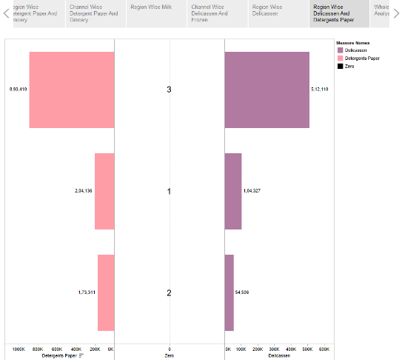

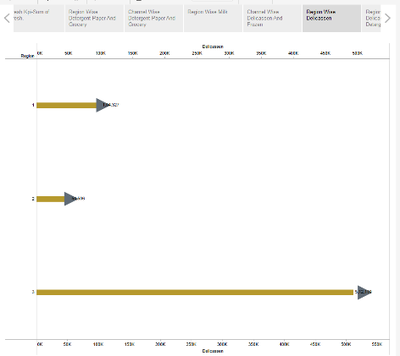 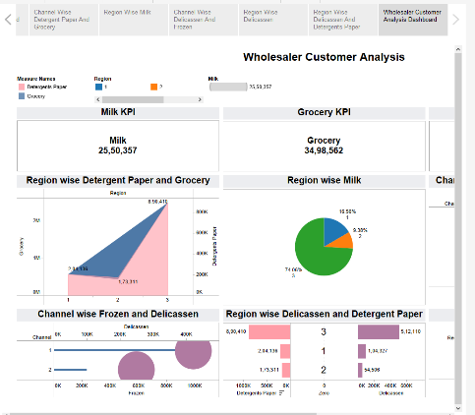

* **ADVANTAGES & DISADVANTAGES:**

* **Advantages** 
  + - * **Informed decision making**

One of the primary advantages is informed decision making. By conducting thorough research, businesses gain valuable insights into customer preferences, needs, and behaviors.

* + - * **Targeted marketing**

Data analysis enables targeted marketing efforts. By understanding the target market, businesses can tailor their marketing messages and strategies to resonate with specific customer segments.

* **Gaining a competitive advantage**

Data analysis provides businesses with a competitive advantage. By monitoring industry trends, customer preferences, and competitor strategies, companies can identify gaps in the market and develop unique selling propositions.

* **Disadvantages**
* **Cost and Time**

The first disadvantage is the cost and time involved. Conducting market analysis can be expensive and time consuming, especially for small businesses with limited budgets and resources.

* **Data accuracy**

The second disadvantage is the potential for data accuracy and reliability issues. The quality of market research data heavily relies on the data collection methods and sample size.

* **Information Overload**

The third disadvantage is the potential for information overload. With the abundance of data available through data analysis, businesses may face the challenge of processing and analyzing large volumes of information.

* **APPLICATIONS:**

Marketing analytics gives you the detailed information you need about the customers to create information you need about customers to create highly targeted materials. Analytics software can predict and determine what consumers want which also leads to a better customer experience based on their profiles, purchase histories and browsing behaviors.

* **CONCLUSION:**

Market research provides significant advantages for businesses, such as informed decision-making, targeted marketing, and a competitive edge. However, its crucial to consider the potential disadvantages, including cost, data accuracy, and information overload.

* **FUTURE SCOPE:**

The future scope of a data analyst looks promising as the demand for market research continues to grow. Within advancements in technology and data analytics, the role of a market research analyst is evolving and becoming more important to businesses and organizations looing to make informed decisions.